NAME: SOMA

PROJECT NAME: ARTVILLE

THEME: WEB DEV

Role:

I made the photography page and review corner in the Artville Webpage

What I learned while building the project:

HTML, CSS

Course names (I referred to while working for the project):

Udemy course: <https://www.udemy.com/share/101v3gAEATcFxWQHgJ/>

Youtube:

<https://youtu.be/mU6anWqZJcc>

<https://youtu.be/yQimoqo0-7g>

Libraries used in the project:

No libraries used

Work flow of the project:

I first created the responsive navbar.

Then I have created the photography page where we have displayed some artworks and a review section.

Screen shots:

GITHUB ACCOUNT LINK: https://github.com/soma-v/ARTVILLE

PHOTOGRAPHY CORNER:

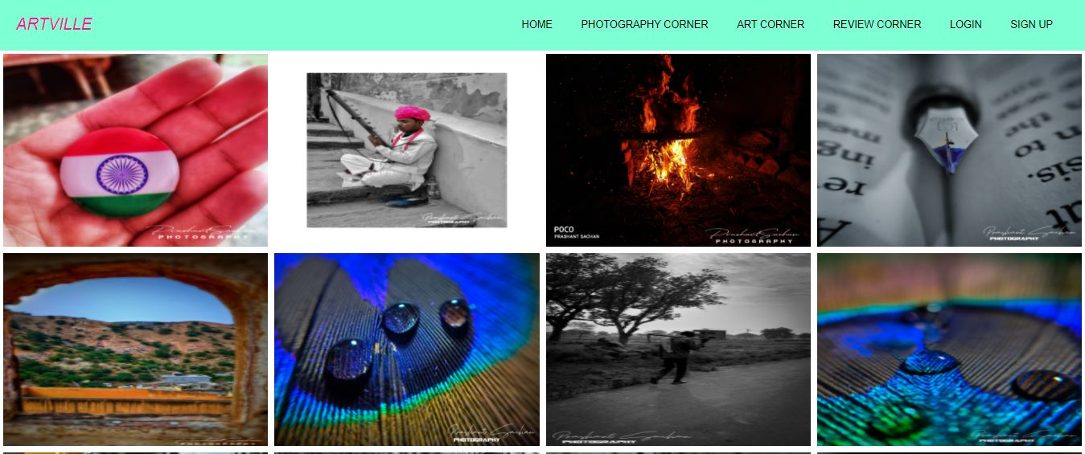

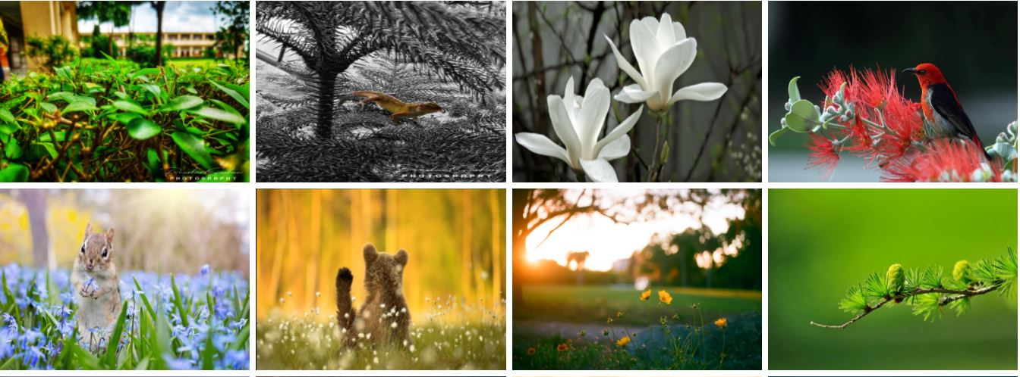

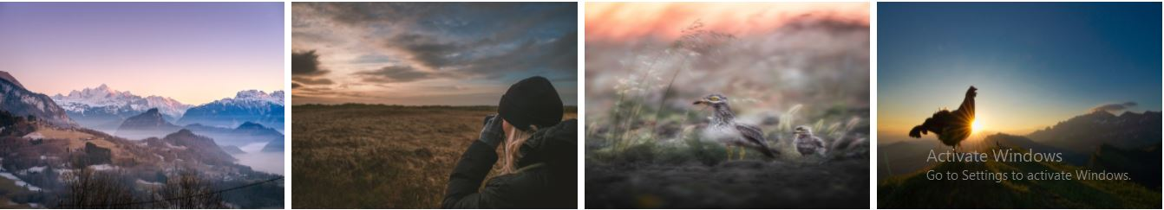

REVIEW CORNER:

